***A Way Home***  
  
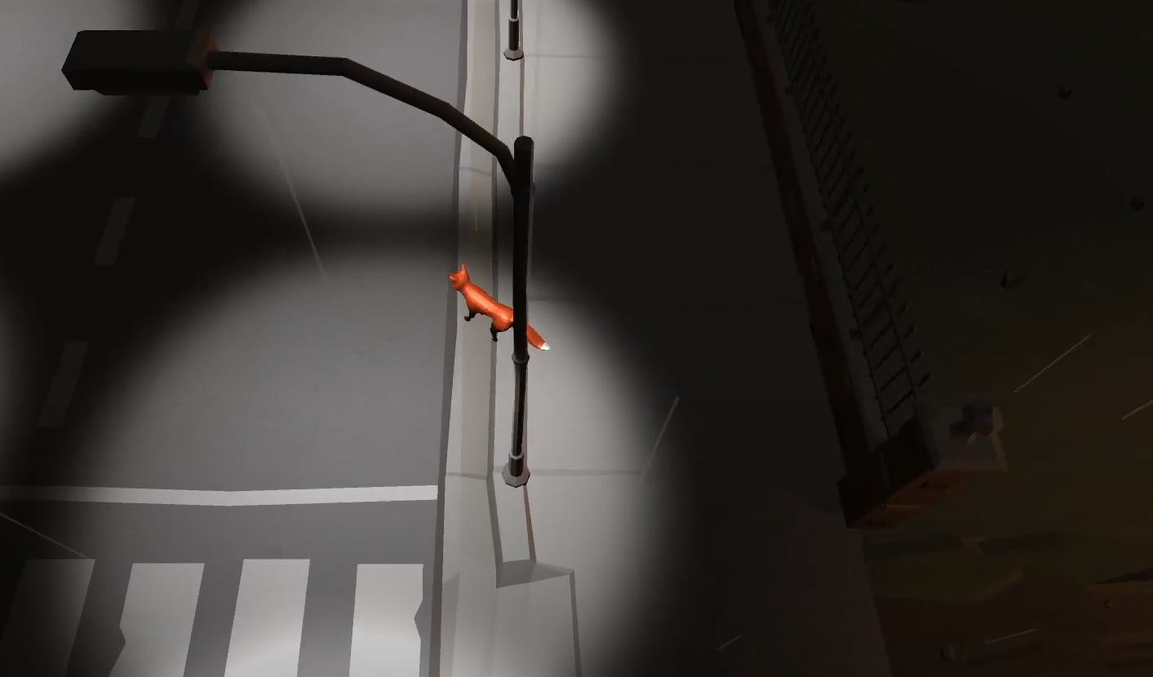

**Contents**

**Design Document**  
Introduction - 3  
Client Brief, Market/Audience Insights - 4  
Concept Solution and Vision - 5  
Designs - 9  
Publishing/Promotion, Testing/Evaluation - 13  
  
**Requirements**  
Introduction, Requirements Table - 14  
Project Plan and Sprints Cycles link, Optimising Risk - 17  
  
**Individual Written Report - 18**  
**References - 20**

**Design Document**  
  
Introduction  
  
Hi, we are the team working on “The Way Home”. Here are our roles!  
  
Rhys - Project Lead, Modelling  
  
Rio - Modelling, Animations, Textures  
  
Dana - Modelling, Textures  
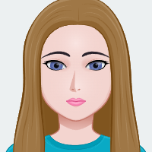  
Elijah - Design, Programming  
  
Zach - Design, Programming **  
We will be covering the brief provided by Typeone, relating to the AR animal project for The Museum of the Home. In this document, we will be presenting our vision and plans going forward to address the brief.

Client Brief  
Our brief initially required us to make 3 3D low-poly models of a Fox, Parakeet and Cat, alongside rigging and animation. Typeone required this for use in the Museum of the Home for an upcoming project featuring an Augmented Reality (AR) exhibit that uses the PlayCanvas engine. The models were recommended to be made in Blender so they are compatible with the PlayCanvas engine.  
*Pictured: Museum of the Home interior and Exterior*  
  
We expanded the brief ourselves, to create a singleplayer game called “A Way Home”, where you can play as the 3 animals in different environments around London, particularly near the Museum of the Home. The game would be for mobile, and be accessible via a QR code, so that it could be placed in the exhibit for visitors to interact with, being as accessible as possible and fit in with the AR theme. The game would be made in Unity (since it's intuitive for mobile game development), and would use the same models originally proposed in the brief. The controls would therefore need to be simple to work on mobile and be accessible to the public visiting the Museum. As a bonus, we will also pay homage to the Museum of the Home by including a custom model of the exterior of the building, which the players can visit.  
  
The overall goal is to have an immersive, relaxed, easily accessible educational experience. The game draws inspiration from “Stray” and “The First Tree”, which are two also very artistic 3rd person games where you play as animals in an immersive environment.  
  
Market/Audience Insights  
Our research showed that the Museum of the home is a standard Museum open to the public, meaning it attracts a wide variety of people. Namely, the most common categories of visitors would be children with their parents, young adults interested in Art or Nature, and older members of society with a taste for artistic displays. This would also include people of all age groups and demographics that may have disabilities. On average, most of these users would have limited experience or skill with video games, likely only experiencing simple mobile games. The Museum itself is focused around the environment and our relationship to it, as well as indoor spaces in modern society and how it has changed over the years.  
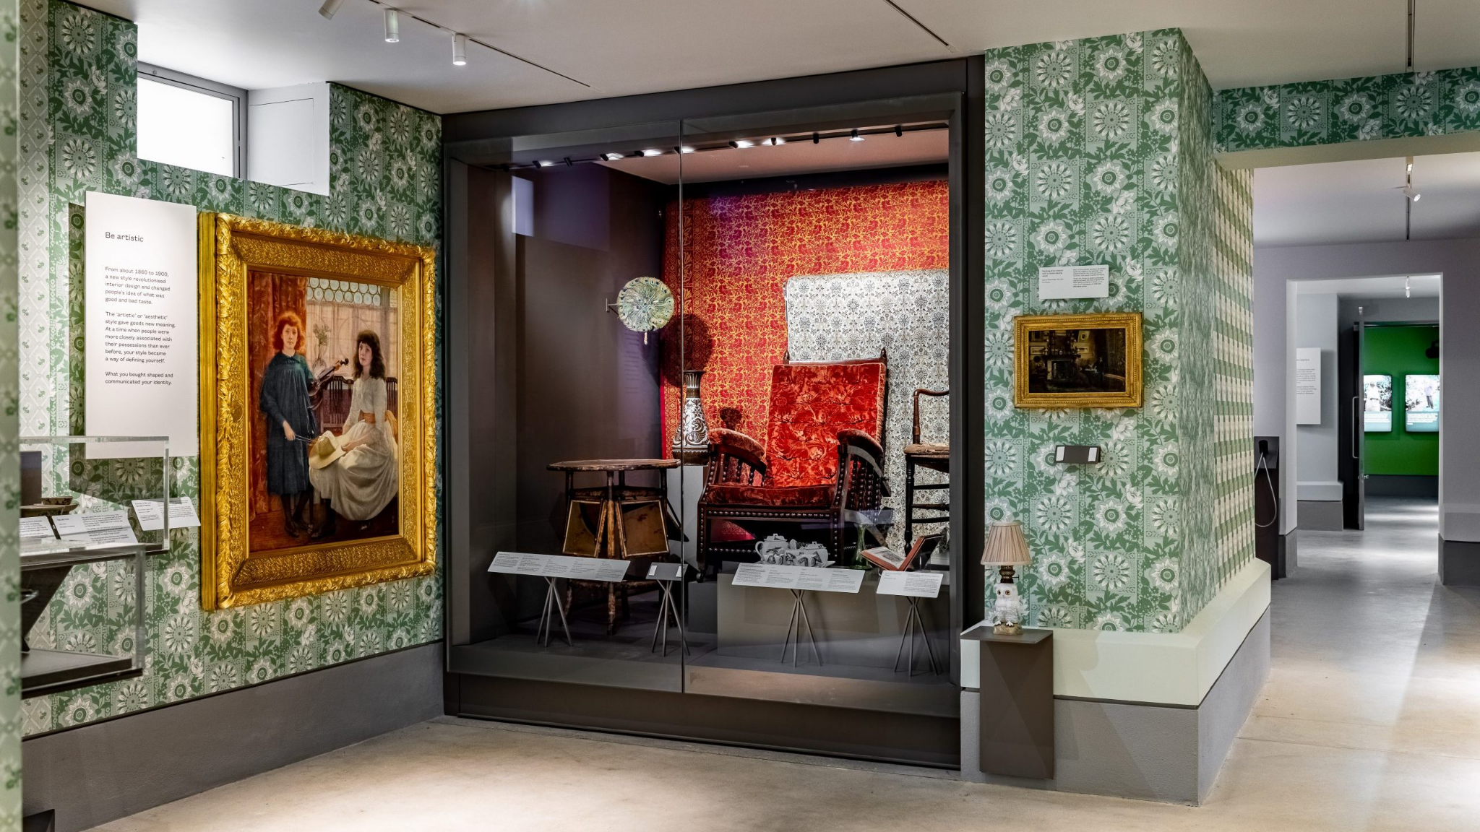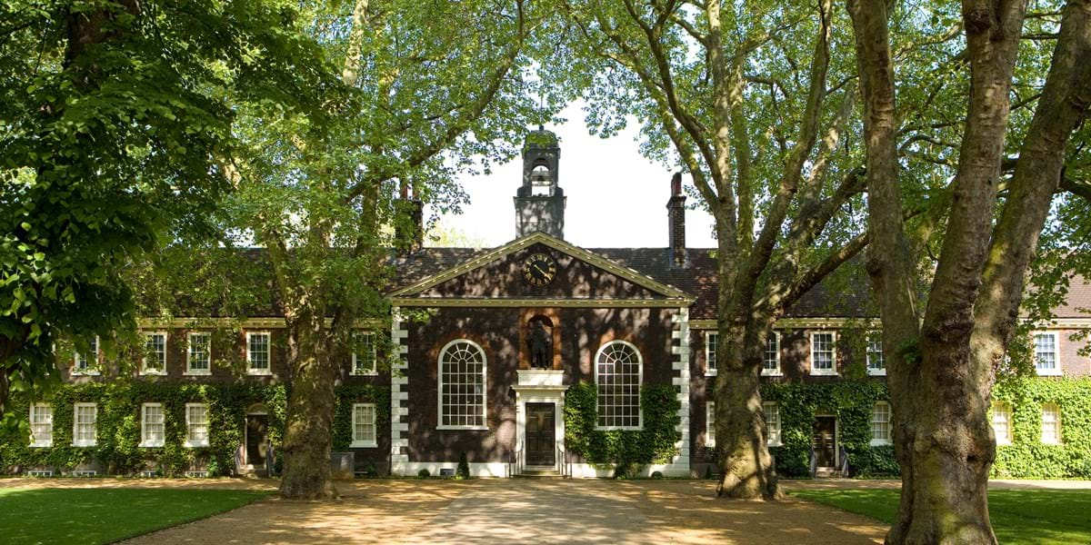

Concept Solution and Vision  
A Way Home is a singleplayer, top-down exploration focused game built for mobile, where you would play as one of 3 animals (A Fox, Parakeet and Cat). Your goal is to try and reach the respective homes for each animal to reunite them with their families. It is set in the urban environments of London, with a mix of manmade and natural areas you traverse. Along the way, you read and follow text prompts providing educational information about the environment. The game has a relaxed pace, letting the player explore with little to no urgency, as there are no hazards or time limit.   
  
*Pictured: Screenshot from the game Stray, a source of inspiration*  
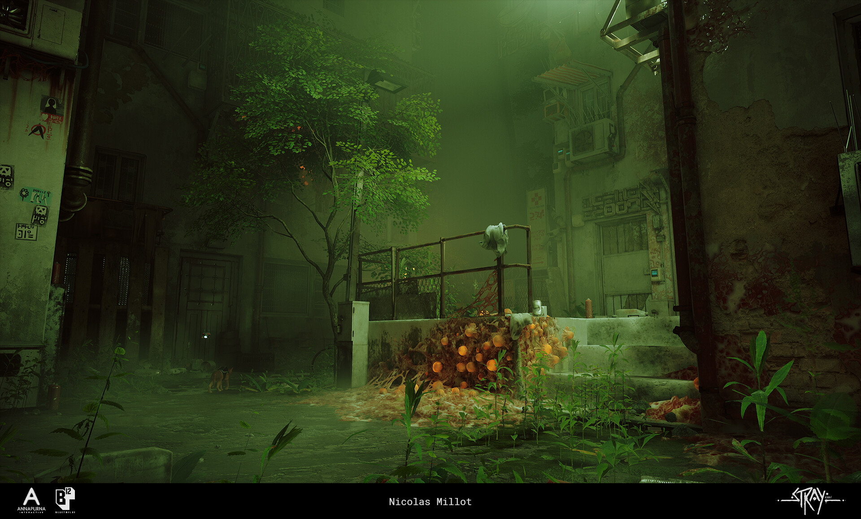  
*Pictured: Screenshot from the game “The First Tree”, another source of inspiration*  
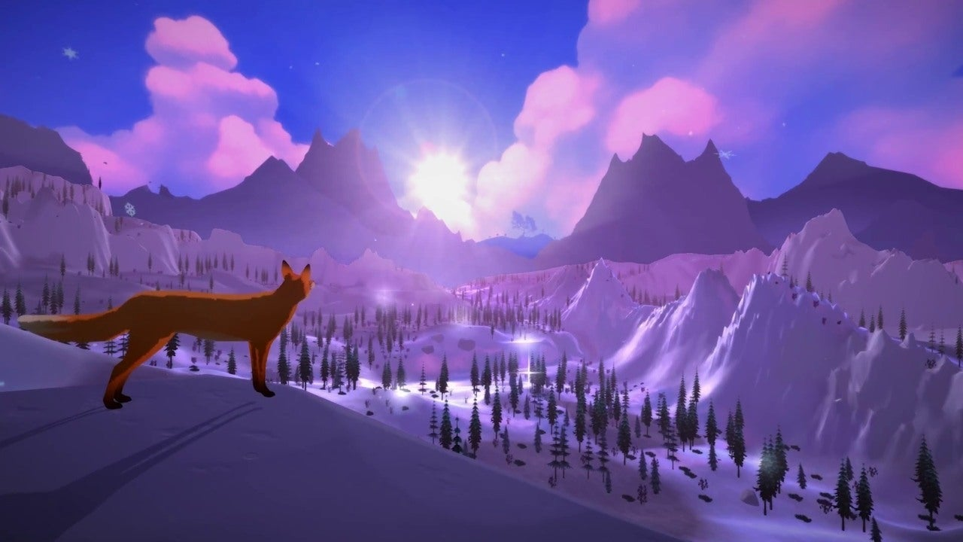

The character is directed around with simple point and click controls to work well with mobile. UI and controls are minimalistic to make it work as best on mobile as possible and to make it as accessible as possible.   
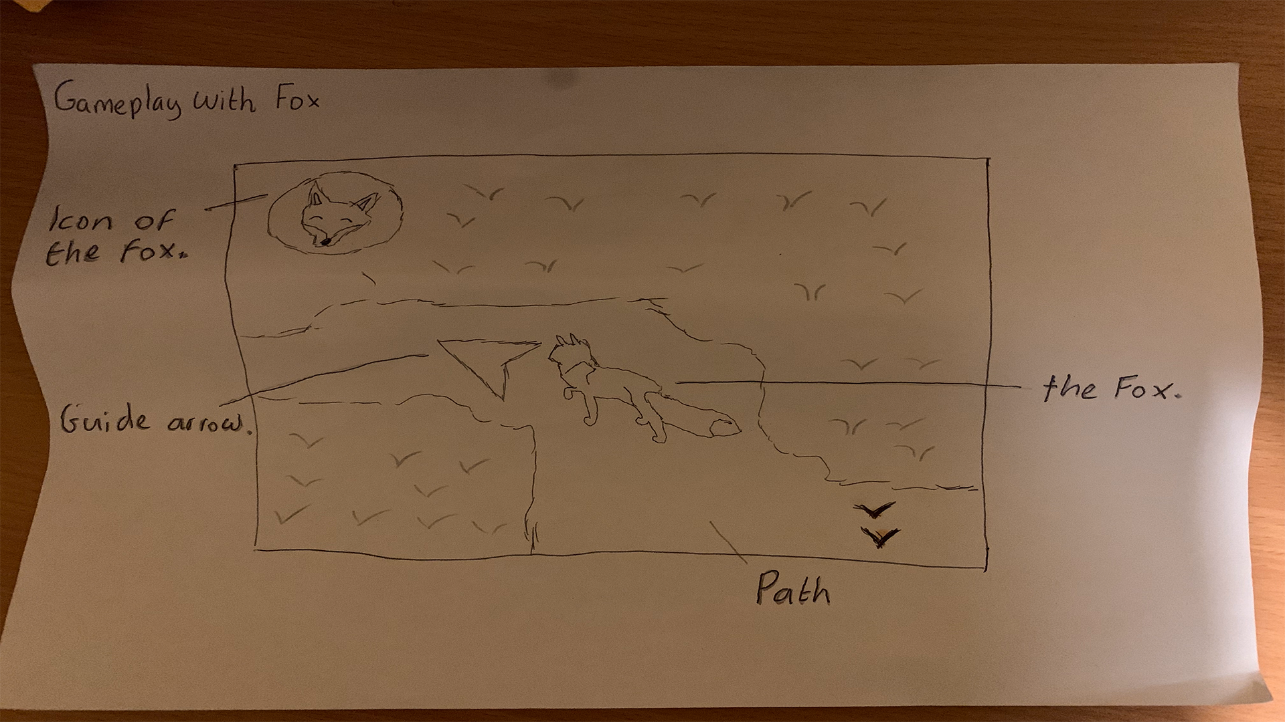  
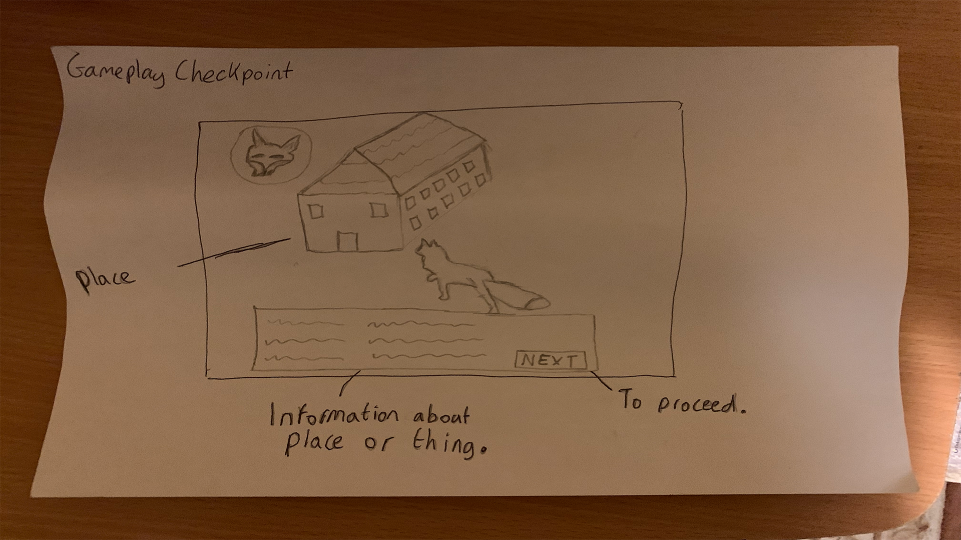  
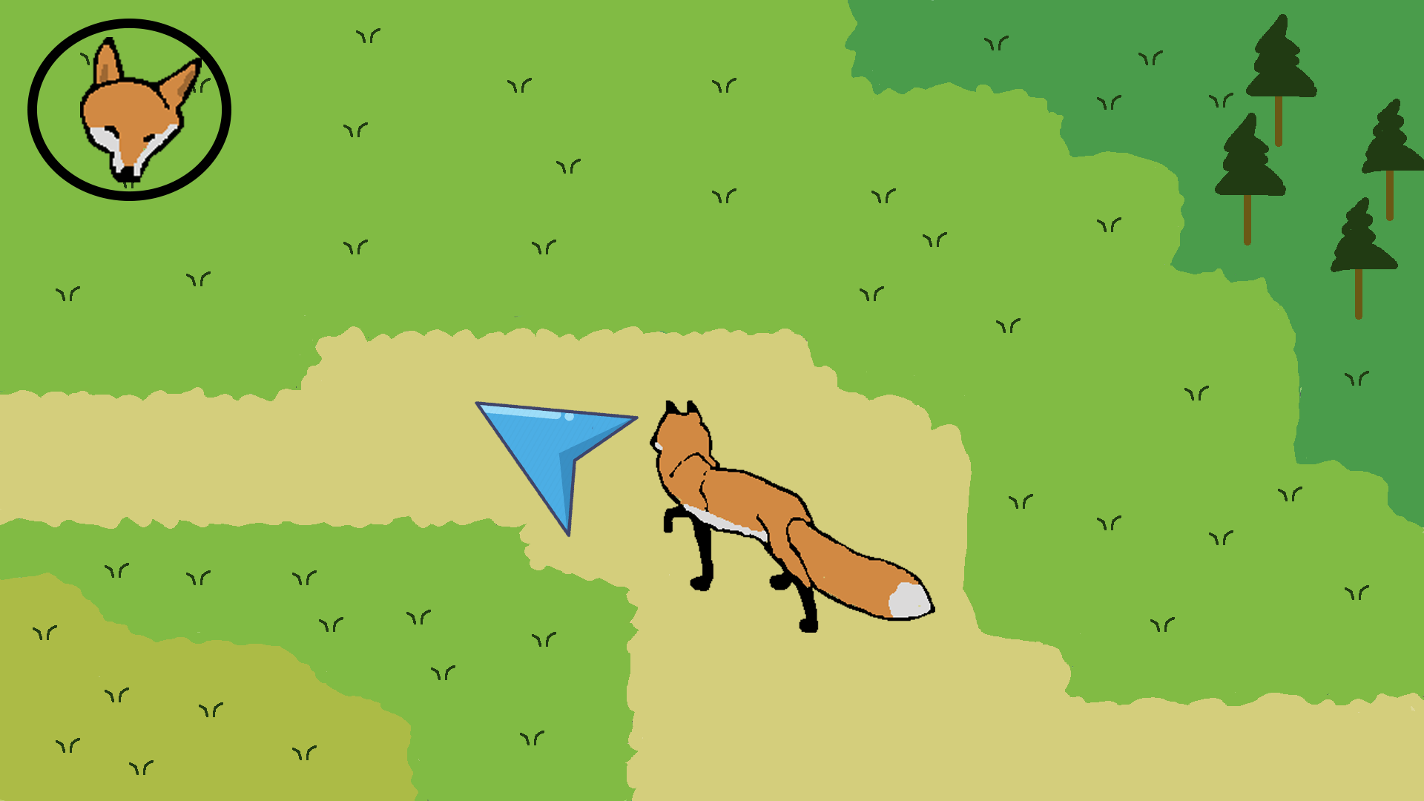  
Each animal will have a unique ability to set them apart, and the entire game will feature a low-poly art-style, with the natural and urban aspects combined seamlessly.   
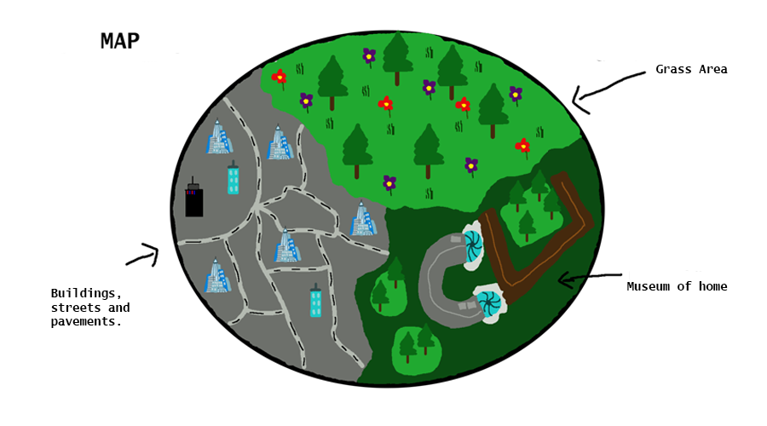  
Since Typeone planned to implement the models as a part of an AR Exhibit at the Museum of the Home, we will make several nods to this, such as having QR codes you can scan in game to bring up relevant information around the flora and fauna found, QR codes you can scan in the real world to gain access to the game, with different codes spawning you in different locations with different characters, and the Museum of the Home’s exterior will be modelled and included in the game.

The UI outside the main game itself would be very simple, just offering some basic options and giving the player access to the game itself.  
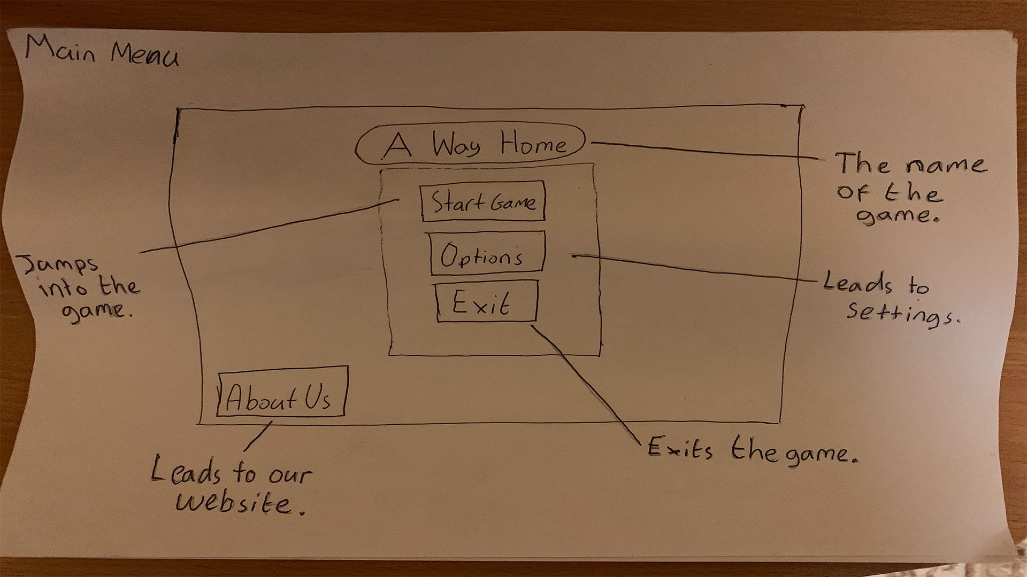  
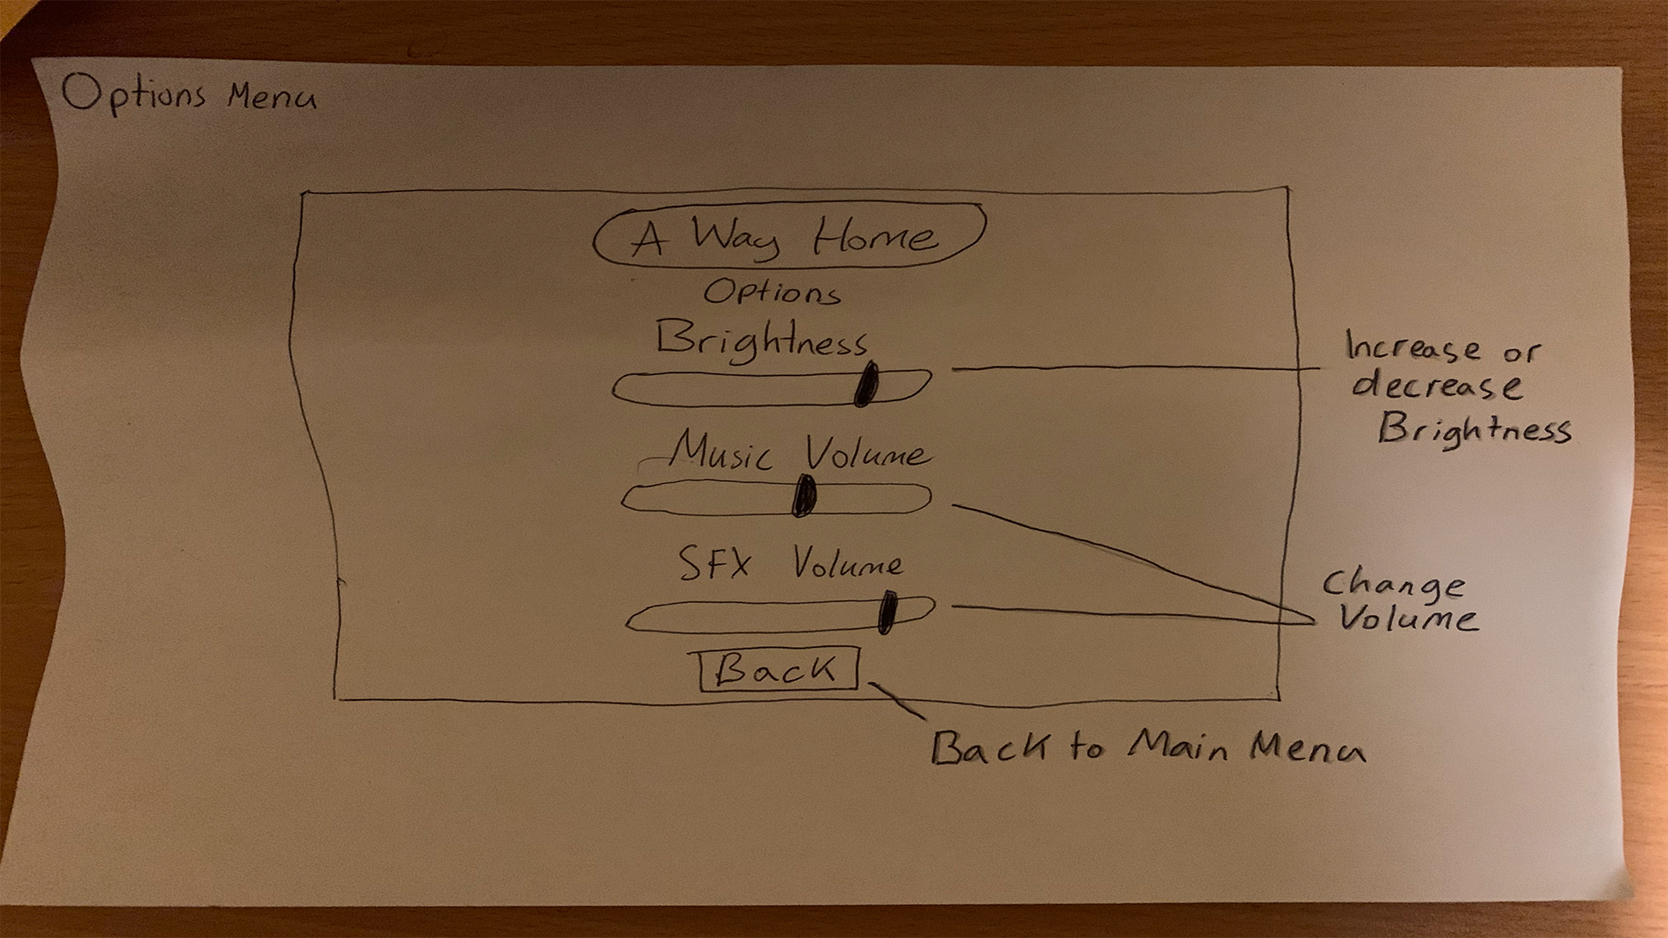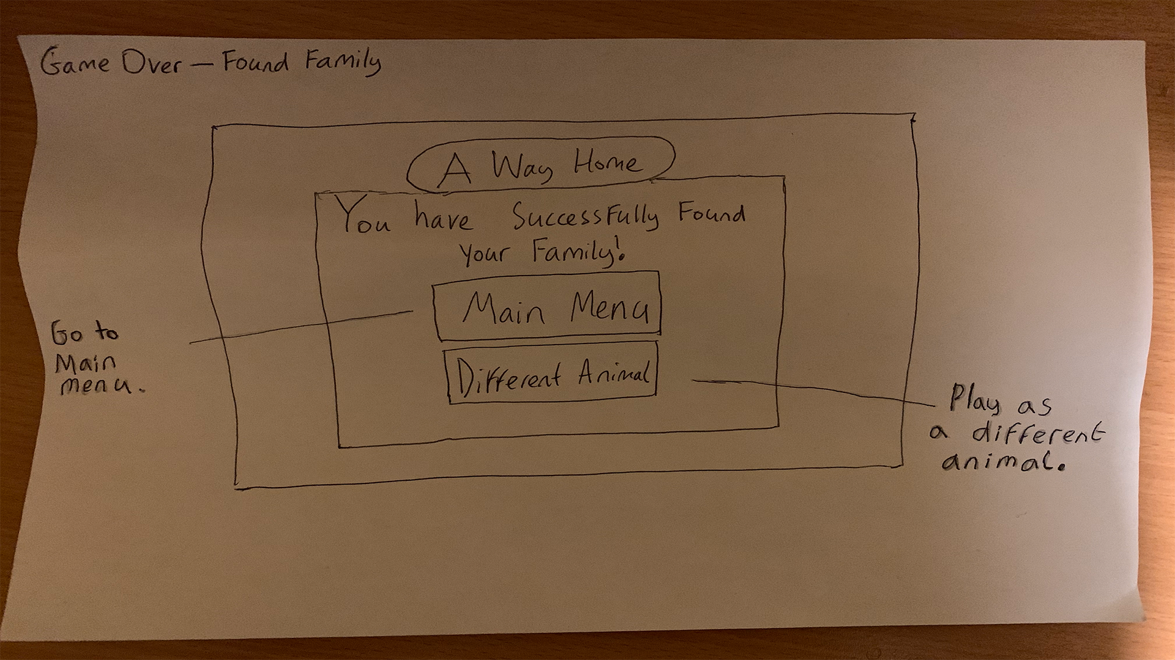  
  
The target platform would be mobile, and the game will be developed in Unity since it offers lots of mobile support options. The low-poly aesthetics should help it run smoothly on mobile platforms. The simplistic UI and controls is aimed at making it as accessible as possible for the target audience found at the Museum, by lowering the barrier of entry to play. This is then further pushed by making the game slow-paced and relaxing, with a focus on the educational aspects and experiencing the environment. This also lines up well with the focus on the Museum itself, since it is about nature and people cohabitating in London. The game itself won’t feature voice acting or a narration, as it is unnecessary and complicates issues regarding keeping it accessible to everyone.  
  
Designs  
To direct the player, there would be an arrow that points them towards their objective. There would also be an icon showing the character they are currently playing as.  
  
*Pictured: a mockup design of the simple UI, camera perspective and colour usage*  


There would also be an indicator to appear whenever the player clicks/touches the screen, showing where their character is currently moving to. This is so they can react and make adjustments if the character is not moving where they want to, and is very simple to understand.  
*Some footage from the prototype, showing the indicator:*  
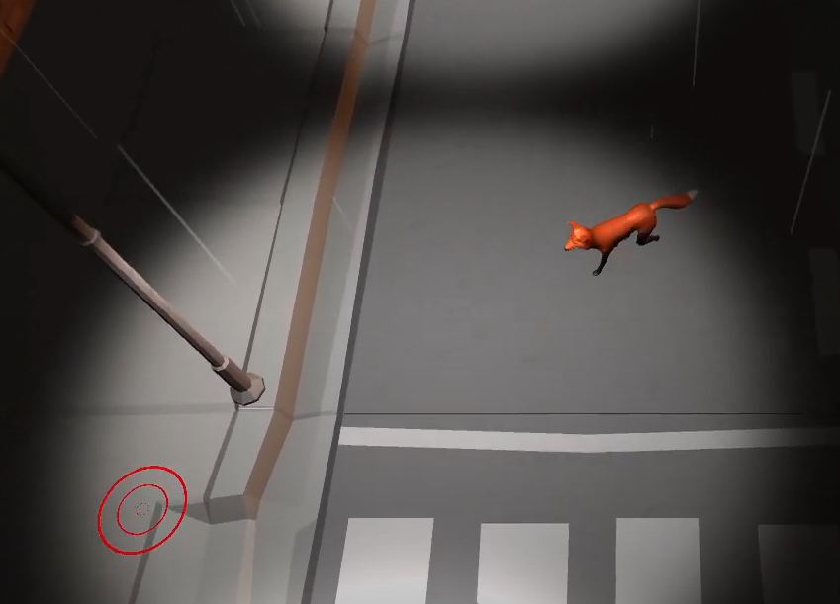  
  
*Museum of the Home design:*  
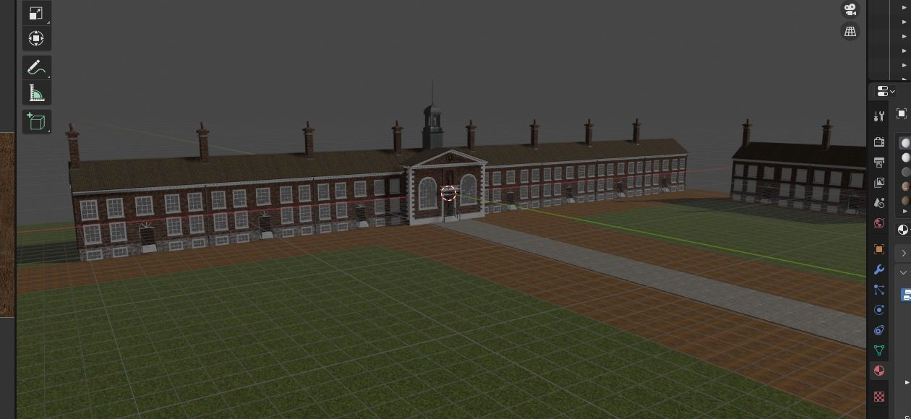  
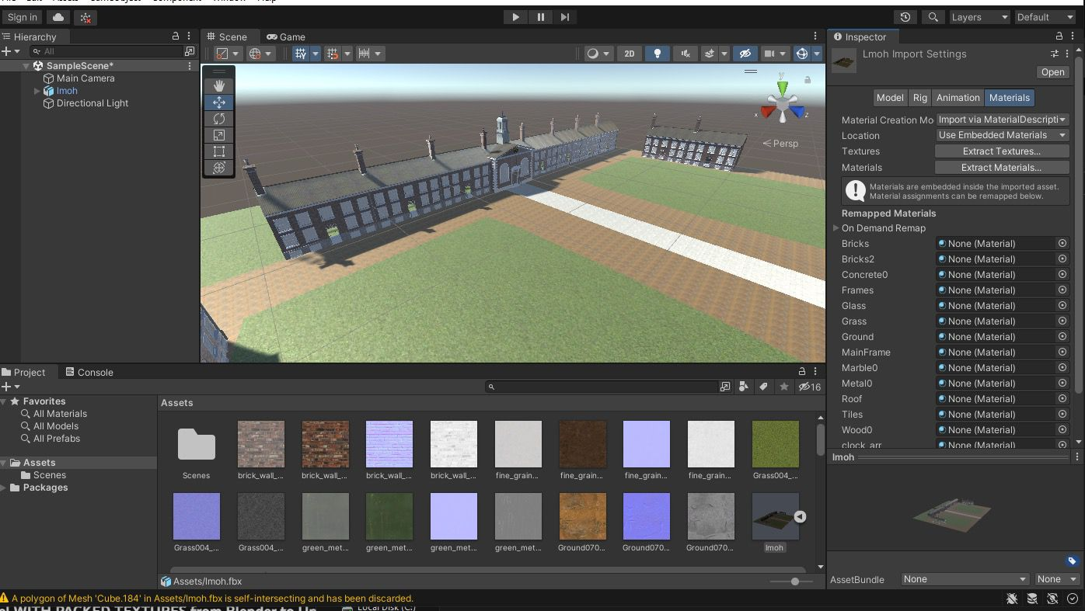  
  
*Reference image:*  
   
  
*Prototype animal models:*

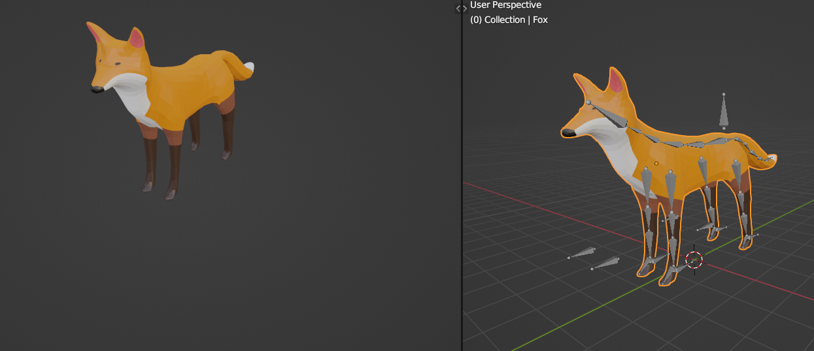

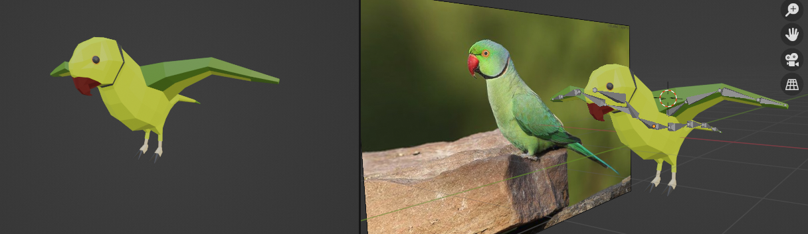  
  
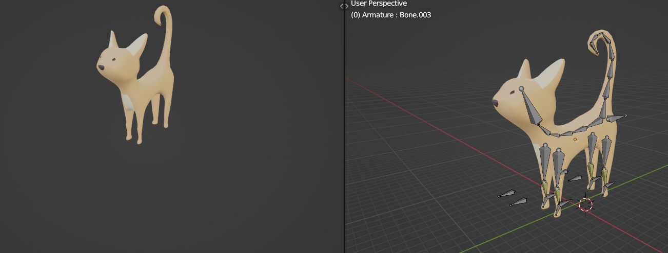  
  
Customer Journey  
Following the AIDA model, we’ll follow the perspective of a young child with a disability or generally having trouble with complex tasks or functions. First we start with Awareness. Awareness would be brought immediately to the child, as the game would be visually appealing, with vibrant colours, eye-catching animations and a positive aesthetic, on a screen inside of the Museum of the Home. It would be comfortable enough it wouldn’t scare the child. Interest would be gained once it shows it is mobile compatible and has a QR code for easy access. It is common for children in Museums to be bored if the Museum is not about something they are particularly interested in (E.g. Dinosaurs for a young male interested in Dinosaurs), and so they would be looking for something to occupy them. The Museum of the Home’s focus on household infrastructure, design, and the environment, would generally not appeal to a child. Meanwhile, the parents/guardians taking them to the Museum may also be looking for something safe to occupy the child whilst they enjoy the exhibits. Upon scanning the QR code and gaining access via their phone (or parent’s/guardian’s phone), they would immediately be treated to access to the game. From this, both Interest and Desire have been obtained. From there, due to how easy it is to access, the action is immediately followed, allowing them to play the game.  
  
Publishing & Promotion  
Initially, the game would be accessible by the target audience inside of the Museum itself. This would be their initial exposure to it. Since we also plan to have QR codes that immediately place you into the game at a location in London, another form of access to the public would be scanning the QR codes found placed in the public around London. In general, it could be released onto an app store, which would be easy to do since it is already made for mobile.  
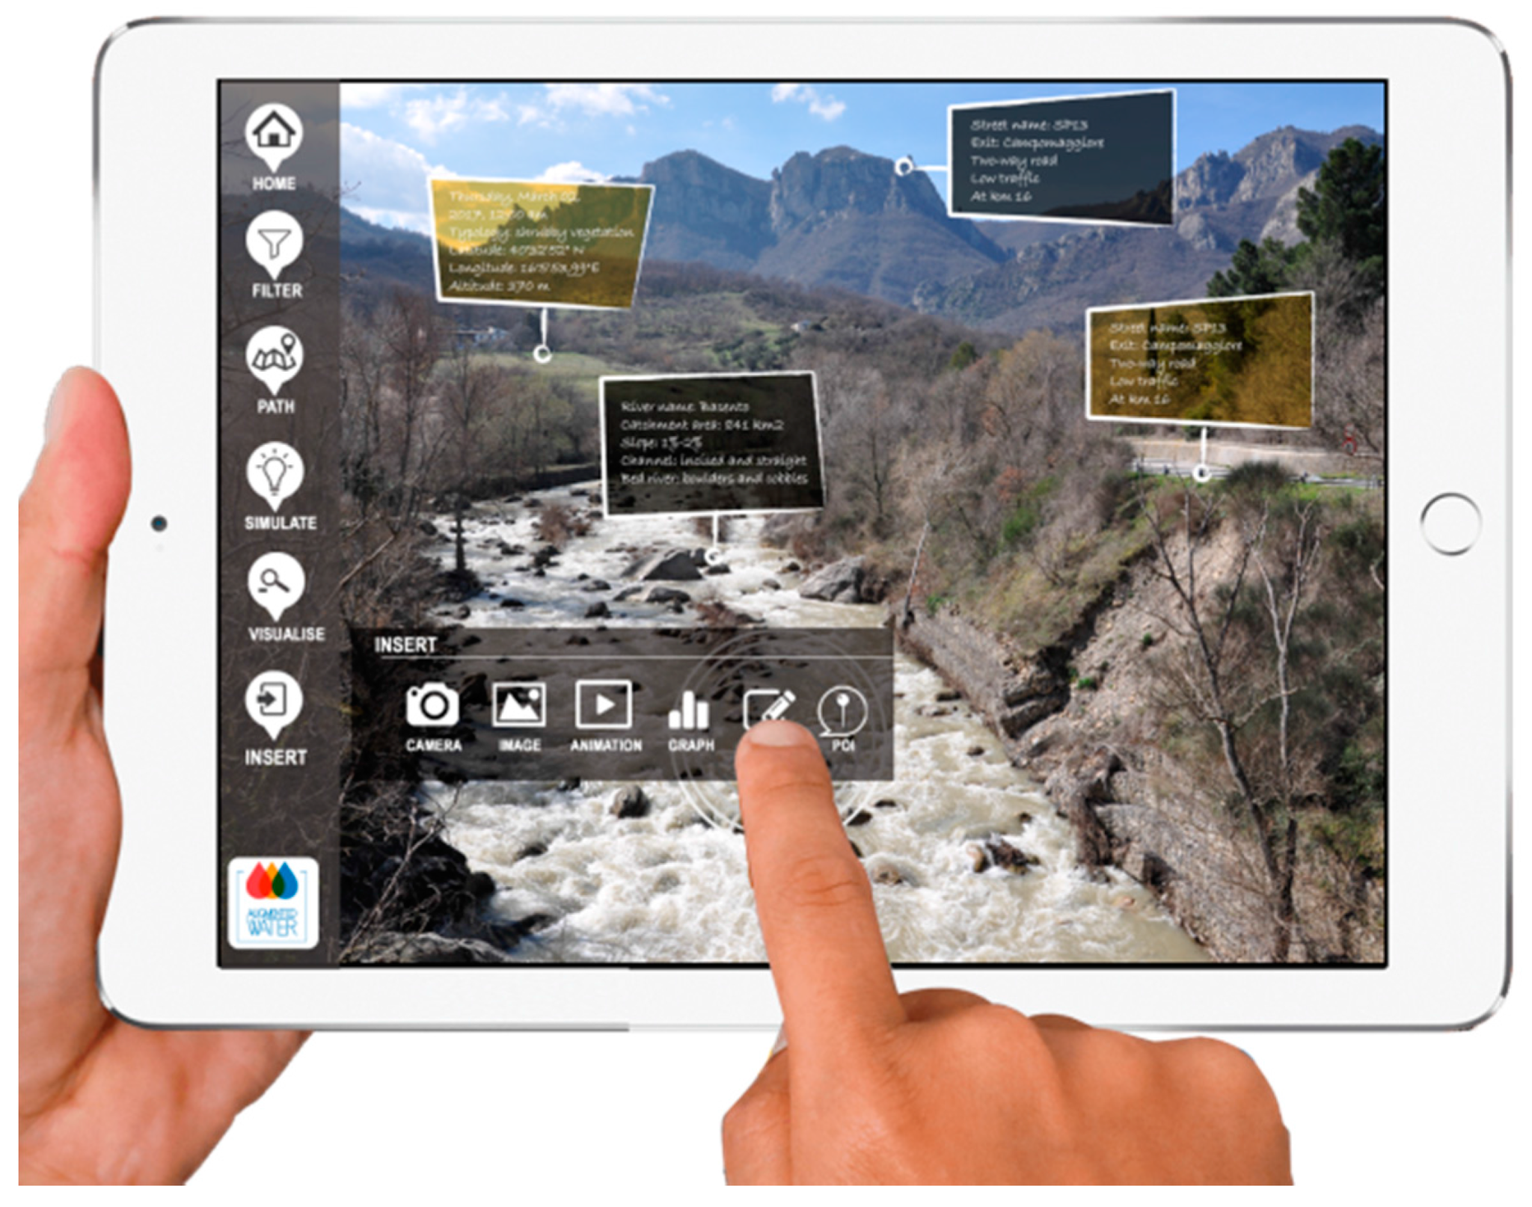  
*Pictured, an example of what the text popups would look like, and a QR code*  
In terms of platforms, the game runs both on windows and on mobile devices. The windows platform is mostly for accessibility, development, demonstration and distribution of the game, whereas mobile is the desired platform for the user.  
  
Testing and Evaluation  
We tested our prototype in Unity, making sure the models and animations looked correct and that the general controls and feel of the game is like we planned. During development of the models, we frequently iterated on them, altering the models with pieces of feedback from other students and our lecturers to get the animals more accurate, such as changing the wing angle on the parakeet.  
  
Our modellers also mirrored the models on each side, to avoid the issue of one side being asymmetrical to the other and assisting the lifelike appearance. In general in terms of our presentation and product pitch, we received criticism that the name “AR Animals” didn’t fit. Whilst it did make sense during development as an in-development internal name since we are making models for an AR implementation by our client, it didn’t make sense from a marketing/promotion point of view, since our game is not an AR game. We then made a more clear distinction about how AR would be referenced in our project, and then changed the name to “A Way Home”.  
  
*Playstation* gave us the feedback of: Make sure the information isn’t boring, find a balance between open world and guiding the player, make the fox & cat more distinct, use lots of references for the animal models & animations, and think more about promotional materials.

**Requirements Specification and Project Plan**  
Introduction  
As a team, Rhys is our Project Leader, who generally guides us onto the right path of what we should be doing in the project. He is also talented in both Unity and in 3D modelling, which are the 2 core aspects of our project, which is why it makes sense for him to be our Project Lead.  
However, we generally operate independently. Together, we came up with our project vision and plan, and we are all on the same page in terms of how the game should look and feel, and what we each need to do to make it. So, from there we are able to act independently on each of our tasks (Modelling, Programming, Designer etc.). Despite this, we still convene with each other to verify our work and make sure we’re not straying too far from the project’s vision.  
  
Requirements

| **Functional Requirements (What it does, more objective)** | **Priority (MoSCoW)** |
| --- | --- |
| **User Functions (QR Code access, platforms, features they have access to)** |  |
| 1. QR codes that connect to each individual level | S |
| 2. Desktop point and click control scheme, along with a windows executable | M |
| 3. Mobile controls that support touchscreen, along with a working mobile app | M |
| 4. QR codes in the levels that give detail on flora and buildings | C |
| **Technical Functions** |  |
| 1. A single sandbox level that the player can spawn into | M |
| 2. Playable Fox | M |
| 3. Playable Parakeet | M |
| 4. Playable Cat | M |
| 5. Custom abilities for each animal | M |
| 6. Individual levels for each character | S |
| 7. An in-game Narrator | W |
| 8. Any kind of Multiplayer | W |
| 9. More than 3 playable animals | W |
| 10. Other animals or pedestrian NPCs that wander around to enhance the immersion | C |
| 11. Point and click/press movement | M |
| **Art, Modelling, Animations** |  |
| 1. Custom Fox model, rigged and compatible with PlayCanvas engine | M |
| 2. Custom Parakeet model, rigged and compatible with PlayCanvas engine | M |
| 3. Custom Cat model, rigged and compatible with PlayCanvas engine | M |
| 4. Museum of the Home model (Exterior) | M |
| 5. Animations for each animal | M |
| 6. Custom models for the other surrounding buildings | C |
| 7. Atmospheric Lighting and Weather | C |
| 8. Ambient sound effects | S |
| 9. Cutscenes/Transitions for swapping characters | S |
| 10. Museum of the Home model (Interior) | W |
| **User Interface** |  |
| 1. Menu that pauses the game and has settings for sound | M |
| 2. Mini-map with directions | S |
| 3. Custom Portrait of each animal | C |
| 4. Scrolling fact bar about the individual animal | C |
| 5. An effect that plays on where the player clicks/presses | S |
| 6. Custom Player cursor for desktop players | C |
| 7. Player Health bar | W |

| **Non-Functional Requirements (Ease of use, Speed, How well it achieves, more subjective)** | **Priority (MoSCoW)** |
| --- | --- |
| **Performance** |  |
| 1. Models are low-poly | M |
| 2. Game runs at least at a stable 60 FPS | M |
| 3. Lighting and weather is optimised to not cause lag or stutters | M |
| 4. No model Z-Colliding in the environment | M |
| 5. No adverse negative effects on an average mobile device (Overheating, running very slow) | M |
| **Gameplay** |  |
| 1. Animals have accurate animations compared to the real life counterpart | M |
| 2. Controls are simple and easy to use on mobile | M |
| 3. Environments are accurate to London urban environments | M |
| 4. Environments are a one-to-one recreation of London | W |
| 5. The mechanics are very simple and straightforward, to the point where no tutorial or long explanations are needed | M |
| 6. Environments are not too complicated to navigate | M |
| **Accessibility** |  |
| 1. Simple Colour-blind accessibility options/filters/modes | C |
| 2. Brightness toggle for darker environments | S |
| **Appeal** |  |
| 1. Text is easily readable | M |
| 2. Facts are accurate, concise and interesting | S |
| 3. The environments and animals aren’t scary | M |
| 4. The environments and animals are pretty | M |

Project Plan + Sprint Cycles  
Both our Gantt Chart and Sprint Plans can be found in here:  
[*https://docs.google.com/spreadsheets/d/1rYIqlaIco_R438GarGeA2bn93wwyqY_I9kt2BkalhyA/edit?usp=sharing*](https://docs.google.com/spreadsheets/d/1rYIqlaIco_R438GarGeA2bn93wwyqY_I9kt2BkalhyA/edit?usp=sharing)  
  
*Optimising Risk*

A couple possible risks we could encounter in the development of this project could be that certain tasks push the sprint goal back but we can manage this by getting others that are ahead, to help out with other tasks. Another one might be that the animals or the environment might seem scary and off-putting for the player. One way we have managed this is by making our models low poly and another method is by making sure there is ample lighting so that the levels are not too dark. However with the animals being low-poly, they may seem unrealistic but by making our animations similar to their real life counterparts, we can avoid the risk of losing a realistic feel to the game. The optimisation of the game will be another risk that will need to be taken into account. To ensure that this risk can be overcome, the game could include a graphics setting that takes away foliage or excess shadows so that it can run smoother on older devices and on mobile.**Individual Written Report   
Elijah Edwards, “A Way Home” Team, working on the Typeone Brief**  
Role Overview  
My role so far on the project has been to handle the design of the project, and management of the group when our project lead has been absent. Later, i am scheduled to be more involved in the programming and testing of the project in Unity.  
  
So far, the main things i have produced was the various presentations we have done, project plans (including a template for my group to use for this report as well as the Design and Requirements document in general), as well as communicate between all members of the team to make sure we are all on track. Whilst i should be demonstrating my programming skills later in the project, right now the planning is more important since Zach has handled the prototyping for us thus far, and is also more experienced in Unity than me.

Personal Insights

In general in terms of design of the project, i looked into the average types of people that would visit the Museum of the Home, as well as the general purpose of the Museum, which has ties to nature and the cohabitation of humans and nature in London. Since the brief wanted 3 animal models, and the Museum visitors are largely children or people with limited gaming experience, and the Museum itself is focused around nature, the idea to make a game where you explore the environment as animals in an educational, relaxed, artistic experience came naturally. Many design considerations came forward from this, such as settling on it being touch screen compatible and a mobile game, with simple controls. This then got elaborated into not including any complex mechanics or UI, to help suit the audience and device it is planned for. Unity made sense as the engine we would develop for, as it fits the criteria for developing a Mobile/Desktop game well, along with the low-poly style required of the models.  
  
The simple bright artstyle i planned out with my team and general look & feel we settled on really worked to the benefit of our target audience, as it fights right in the exhibit, works well on mobile, and is appealing and easy to understand, especially for children.

Ethics

Within the confines of my role, my main legal/ethical issue would be around using patented code or any other kind of “code stealing” or stealing assets. This is managed by me by ensuring that i either produce everything on my own, or anything else i bring in i credit fully and make sure it is open source and safe to use in the project.  
  
In terms of design, technically many ethical issues can come up, such as the portrayal of animals, animal cruelty (if we aren't careful and depict bad things happening to them), as well as the environment in general, and creating a product aimed at children. Most of these ethical issues are solved by me by doing research into these fields and making sure all work i produce aims to avoid anything controversial. Specifically since children and the Museum are involved, i must be careful to not try to “sell” anything in this product as it is part of an exhibit, and to make sure the content is appropriate for the general public, with nothing that would put it over a PEGI 3+ rating.

Contributions

Besides the designs and documentation so far, i have contributed to my group by keeping everyone closely communicated and making sure everyone is on the same page as to where we are going forward in the project. The presentations we used in both sessions was largely produced by me by going to each person and seeing how i could include their work and explain our project idea well.  
  
Due to a few occasions where our project lead was absent, i had to step in to keep everything on track. This was especially prevalent in the week leading to our presentation to PlayStation, as i had to make sure everyone knew what to produce in time for the presentation and put it all together in a presentable way to best showcase our work for solid feedback going forward.

Feedback

For feedback, i spoke to the team at PlayStation london to ask for feedback on our presentation we gave to them. i made sure to take notes of the feedback, and ask each judge who was listening to our project for feedback. We also got direct feedback from our lecturers that the project leaned too much towards AR, and that we needed to distinctly separate it from AR by not having it be called “AR Animals”, and instead come up with the name “A way home”.

Reflection

I learnt that sometimes briefs can be challenging since the client often doesn’t provide anywhere near enough information, meaning you need to really carefully think about how you can expand it to make a more concise project plan whilst still ultimately providing something the client is happy with. I had to address this myself with my group by figuring out what we can do to expand beyond just “produce 3 animal models” to create an interesting and clear brief. In the future, i believe we should communicate more with our client Typeone or the Museum of the Home (Typeone’s client) to get a better understanding of how we can produce something suitable to their customers,and to save time around having to revisit and adjust our existing work.

**References**  
  
[Stray, a source of inspiration](https://youtu.be/4uP2MyUL49s)  
  
[The first tree, a source of inspiration](https://www.youtube.com/watch?v=BEXIGytnOio&pp=ygUOVGhlIEZpcnN0IHRyZWU%3D)  
  
[Museum of the Home, explaining its origin and purpose](https://www.museumofthehome.org.uk/what-we-do/our-story/)  
  
[Aida Customer Insight Model](https://www.smartinsights.com/traffic-building-strategy/offer-and-message-development/aida-model/)